



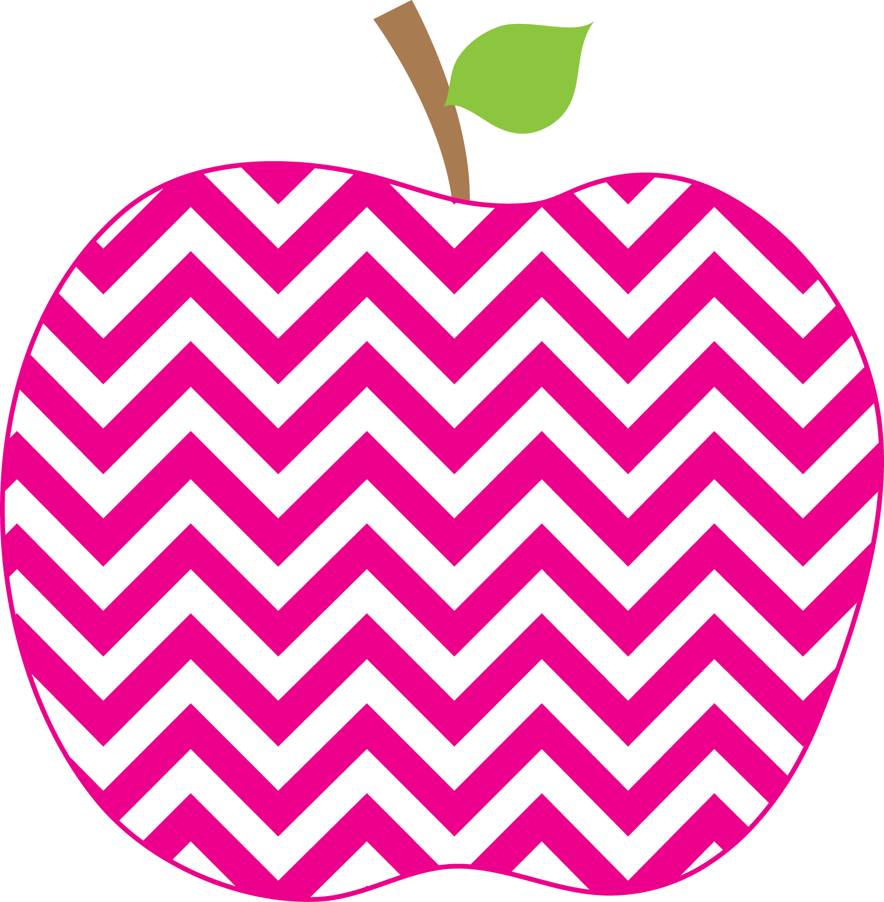

Weekly News

MRS. HOLLOWAY’S CLASS Dec 5th SSept.12t19Sep16th

Literacy-

The sight words for the week are: into, mother, big, get, play

Discussing the sound of oi and oy

Reviewing the name of, sound of and formation of Q. This is our last letter!

We will be reviewing many spelling patterns this week such as : ar, ue, oo, ow, bossy R sounds

We now have our Fancy Nancy Word Wall in place and students are beginning to use some of these words in their writing.

Writing
This week we will work on a different style of writing, Lists. We will also be writing about the snow days last week.

Math-
We continue to count by 2’s to 20, but we have been focusing on counting by 5’s to 50, many are able to count to 100. We have worked on estimation and students are progressing well, but we will continue with more work on this area. Mrs. Coulombe and I are now doing flexible math groups, so if your child mentions going to her class, this is why. We are focusing on specific outcomes that students need additional support with.

You and Your World-
How Animals Prepare for Winter

Learning Focus for the Week
Mrs. Hanscombe and her class did a Presentation, Ring the Bell to talk about the importance of Mental Health and taking care of our brain.
Just a reminder that our Holiday Concert will be held on Dec 14th at 9 and again at 11 am.

It sure is looking a lot like Christmas with the recent snowfall. Please make sure your child wears snow pants each morning and has an extra pair of mittens and socks in their book bag. They play outside each day unless the temperature drops below -20 degrees. Playground winter safety rules were reviewed with the students on Friday.
Homework
I decided to mix it up a bit for homework. This week your child will read the directions for Make your Own Snowflake and will follow the directions! For Math, I have included a sheet for counting in different ways.
Information

